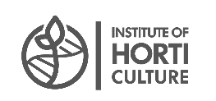

Seminar protocol

The first public seminar organized by the Estonian partners from the Estonian University of Life Sciences took place online on 15th September within the framework of the EEA and Norwegian grant, titled INnovative TEchnologies for REcovery of valuable compounds from agri-food and seafood side STreams for food applications (INTEREST). Three already collaborating partners, Latvia, Norway and Estonia, were seeking interested partners for consortia in application under the Horizon Europe call Cluster 6.

Representatives of governmental and non-governmental organizations, as well as enterprisers, participated in the audience of almost 50 together with scientists.

During the seminar, representatives of scientific institutions, incl. PhD students, provided insights into their research, emphasizing the research infrastructure and collaborative projects. A discussion has been started between the partners about the initial ideas, activities and possible partners of the planned joint project.

The link with the video recording of the 15.09.2023 seminar:

<https://www.darzkopibasinstituts.lv/sites/dobele/files/files/projects/video%2015_09_23%20seminar.mp4>

